EXPERIMENT 7: Selection Sort on Random, Reverse and Sorted Arrays

Aim:
To write a Python program to implement Selection Sort on random, reverse-sorted, and already-sorted arrays and analyze its time complexity.
Algorithm:
- Start.
- Define three arrays:
  - Random array
  - Reverse-sorted array
  - Sorted array
- Find the smallest element from the unsorted portion of the array.
- Swap the smallest element with the first element of the unsorted portion.
- Repeat the process until the complete array is sorted.
- Display the sorted arrays.
- Analyze the time complexity.
- Stop.
Source Code:
def selection_sort(arr):
n = len(arr)

for i in range(n - 1):
min_index = i

for j in range(i + 1, n):
if arr[j] < arr[min_index]:
min_index = j

arr[i], arr[min_index] = arr[min_index], arr[i]

return arr

# Random Array
random_array = [64, 25, 12, 22, 11]

# Reverse Sorted Array
reverse_array = [50, 40, 30, 20, 10]

# Sorted Array
sorted_array = [10, 20, 30, 40, 50]

print("Random Array:")
print("Before Sorting:", random_array)
print("After Sorting :", selection_sort(random_array.copy()))

print()

print("Reverse Sorted Array:")
print("Before Sorting:", reverse_array)
print("After Sorting :", selection_sort(reverse_array.copy()))

print()

print("Sorted Array:")
print("Before Sorting:", sorted_array)
print("After Sorting :", selection_sort(sorted_array.copy()))
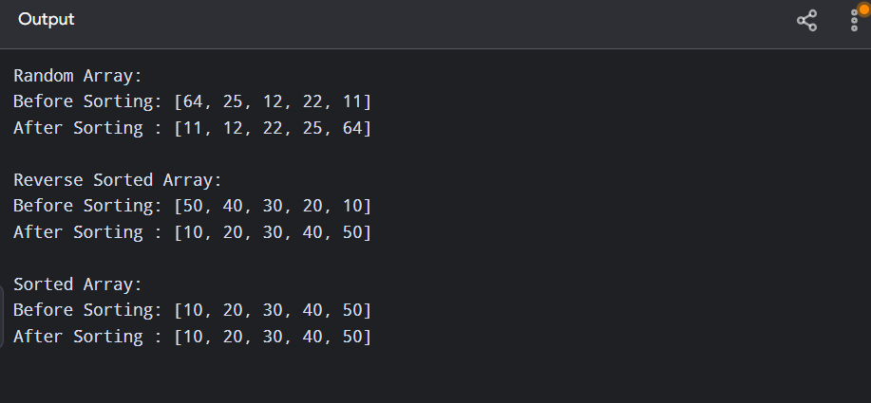

Result:
Thus, the Selection Sort algorithm was successfully implemented for random, reverse-sorted, and sorted arrays, and its time complexity was analyzed.

